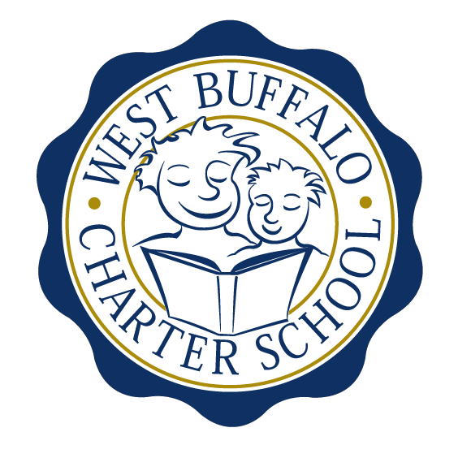
West Buffalo Charter School

Board of Trustees Meeting
September 28th, 2015
2:30 PM
D’Youville College
Bauer Family Academic Center, Room 105

Minutes

Board Members:
Present: Arup Sen, James Deuschle, Michelle Stevens, Joanne Haefner, and
James Sampson

Excused: Joseph Cozzo, Lucy Candelario and Richard Baer
Quorum Present: Yes
Also Present: Andrea Todoro, Liz Sterns, Lee Pearce and Cynthia Stark

Call to Order
Dr. Sen called the Meeting to order at 2:40 PM. Quorum present.

Proof of Public Notice of Meeting
Media and public announcement was sent on Monday, September 21st, 2015 to print, radio, and TV outlets announcing this open meeting. A posting was also sent to Erie County Hall, Buffalo City Hall and Buffalo City Court. In addition, it was publicly displayed at 50 East North Street and posted on the WBCS website. The Board of Trustees was duly notified of this meeting well within the timeline of our bylaws.

Review of the August 24th, 2015 Meeting Minutes
Minutes of the August 24th, 2015 Board of Trustees meeting were presented for approval.

Upon motion duly made by Mr. Deuschle and seconded by Mrs. Stevens, the minutes of the August 24th, 2015 board meeting were approved as presented. All in favor. Non-opposed.

- Discussion regarding expansion outline. Documents will be furnished to the board one week prior to the October meeting for review prior to submitting to SED.
- Extensive discussion took place regarding facilities expansion.

School Leader Report

- Mrs. Todoro presented the School Leader Report for the period ending August 31st, 2015 (a copy of which is attached hereto and made a part hereof).
- Mrs. Todoro reported on the results of meetings that took place with this year’s teachers in regards to last year’s data from the 3rd and 4th grade test scores. The meetings produced insights into how teachers can benefit from each other’s individual strengths and how the students benefit in the long run.
- Mrs. Todoro provided information regarding 1) Transgender and Gender Nonconforming Students and 2) Administration of Naloxone in School Setting.
- Board approval needed for WBCS to become a State registered site.

Upon motion duly made by Mr. Sampson and seconded by Mr Deuschle, the board approved as presented the motion to approve that WBCS become a New York State registered site for administering Naloxone. All in favor. Non-opposed.

- Discussion regarding staff turn-over due to outside recruitment.

Financial Report

- Mrs. Sterns presented the financial report for the period ending August 31st, 2015 (a copy which is attached hereto and made a part hereof).

Upon motion duly made by Mrs. Stevens and seconded by Mr. Sampson, the August 31st, 2015 financial statements were approved as presented. All in favor. Non-opposed.

Upon motion duly made by Mr. Sampson and seconded by Mrs. Stevens, the board approved as presented the MOU between Arts Partners for Learning, managed by Young Audiences and WBCS. All in favor. Non-opposed.

- Discussion regarding an RFP to retain a law firm that is Charter-specific. Mrs Sterns provided three potential options. The RFP will be provided to the board prior to the October meeting.
- Mrs. Sterns and Mr. Deuschle met during the month to review the end of year financials and to adjust as needed prior to the upcoming financial audit.

Adjournment

There being no further business to discuss, a motion to dismiss was made by Mr. Sampson and seconded by Mr. Deuschle. The meeting was adjourned 4:10 PM.

Respectfully submitted,
Leslie Bunis Ohl

The next board meeting is scheduled for Monday, October 26th, 2015 at 2:30 PM at D’Youville College (Bauer Family Academic Center-BFAC, Room 105).

